

SUREKEY EXAMINATIONS BOARD

**PRIMARY SIX QUALITY CHECK TWO EXAMINATION**

2024

SOCIAL STUDIES WITH RELIGIOUS EDUCATION

***Time Allowed: 2 hours 15 minutes***

**School Admission No. Personal No.**

**Pupil’s Name:** ……………………………………..………………………..………………………..

**Pupil’s Signature:** …………………………………………………………..……………………….

**School Name:** …………………………………………………………………………………………..

**District Name:** …………………………………………………………………………………………

**Read the following instructions carefully:**

**FOR EXAMINERS’**

**USE ONLY**

**Qn. No. MARKS EXR’S**

**NO.**

1 – 10

11 − 20

21 – 30

31 – 40

41 – 43

44 – 46

47 – 49

50 – 52

53 – 55

**TOTAL**

1. Do not forget to write your **school** or

**district name** on the paper.

1. This paper has two sections: **A** and **B**. Section **A** has **40** questions and section **B** has **15** questions. The paper

has **12** printed pages.

1. Answer **all** questions. **All** working for both sections **A** and **B** must be shown

in the spaces provided.

1. **All** answers **must** be written using a **blue**

or **black** ball point pen or ink. Any work

written in pencil will **not** be marked.

1. Unnecessary **changes** in your work and handwriting that cannot be read

easily may lead to **loss of marks**.

1. Do not fill anything in the table indicated:

**“For Examiners’ use only”** and boxes

inside the question paper.

***©*** *2024 Surekey Examinations Board 0700758668* **Turn Over**

**SECTION A: 40 MARKS**

Questions **1** to **40** carry **one mark** each

1. State any **one** cause of increased child labour in our communities.

………………………………………………………………….………………………………….……

1. Give any **one** way democracy is practiced in your school.

…………………………………………………………………………………………………….…….

1. Give a reason why the wind-ward side of a mountain has thick vegetation.

…………………………………………………….…………………………………………………….

1. Mention any **one** special group of people represented in the parliament of

Uganda.

………………………………………………………………….……………………………….………

1. State any **one** characteristic of rift valley lakes.

…………………………………………………………………………………………………………..

1. How does the East African Development Bank (EADB) benefit the

East African Community (EAC) member states?

………………………………………………………………………………………………………......

1. What is meant by the term Urban-Rural migration?

…………………………………………………………….……….……………………………………

……………………………………………………………………………………………………………

1. Apart from using some animals for transport, how else can the road

transport challenge be solved in mountainous areas?

……………………………………………………………………………..……………………………

1. Write any **one** country in East Africa which lies in both the Northern and

Southern hemisphere.

………………………………………………………………………………………………..….….…

1. State any **one** way Newspapers promote the development of a country.

………………..…………………………………………………………………………………………

1. How did the 1967 constitution affect cultural institutions in Uganda? …………………………………………………………………………………..…………………….

**2**

1. State any **one** factor that favours the growth of Arabica coffee on the

slopes of Mt.Elgon.

…………………………………………………………………………………………………………

1. Give any **one** reason why the British wanted land in Uganda.

………………………………………………………………………………………….…………….

1. How was Kabaka Mwanga a threat to Christianity in East Africa during the

19th Century?

…………………………………………………………………………………………………………

1. What does the road sign below inform the road users?



…………………………………………………………………………………………………………

1. State any **one** problem resulting from the production of similar goods by

East African countries.

…………………………………………………………………………….…………………………..

1. Name the last dynasty to rule over Bunyoro-Kitara empire before its

final collapse.

…………………………………………………………………………………………………………

1. In which **one** way is smuggling a threat to a country’s development?

…………………………………………………………………………………………………………

1. Give any **one** reason why it is important for a family to make periodic

family budgets.

…………………………………………………………………………………………………………

1. Give **one** reason why the early explorers to East Africa were so much

interested in finding the source of River Nile.

…………………………………………………………………………………………………………

1. In which **one** way does poaching affect wildlife?

…………………………………………………………………………………………………………

**3 Turn Over**

1. Give any **one** way the Judiciary promotes the rule of law in the country.

…………………………………………………………………………………………………………

1. Write any **one** tree species common in the equatorial rainforests.

…………………………………………………………………………………………………………

1. State any **one** problem facing the Uganda Police force.

………………………………………………………………………………………………………..

1. Give any **one** reason why some tribes in Uganda were unable to form

kingdoms.

…………………………………………………………………………………………………………

The picture below shows a certain community found in Uganda. Use it to answer questions **26** and **27**.

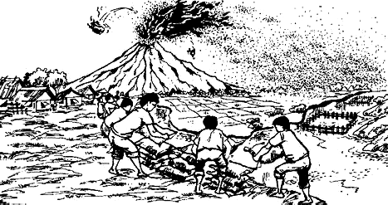

1. Identify any **one** natural disaster that may occur in the above community.

…………………………………………………………………………………………………………

1. State any **one** way people in the above community can manage to stay

safe from the natural disaster mentioned in (a) above.

………………………………………………………………………………………………………..

1. Name the feature on the Uganda Coat of Arms which signifies culture

and communication.

………………………………………………………………………………………………………..

1. Why is wind regarded as a renewable resource?

……………………………………………………………………………………………………….

1. Give any one reason why Uganda should cooperate with her neighbours.

……………………………………………………………………………………………………….

**4**

1. On a map, the distance between the kitchen and the office is 5cm.

Find the actual ground distance between the two places using a scale of

1cm =100km.

……………………………………………………………………………………………………….

1. How is the creation of new local governments in Uganda benefiting the

local people?

…………………………………………………………………………………………………………

The diagram below shows two population distribution patterns **P** and **Q**.

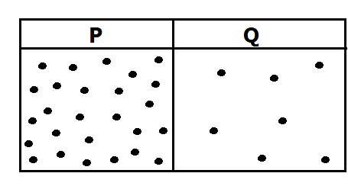Use it to answer questions **33** and **34**.

1. State any **one** factor that can lead to a population distribution pattern **P**.

…………………………………………………………………………………………………………

1. Give any **one** challenge an area with a population distribution pattern **Q**

is likely to face.

…………………………………………………………………………………………………………

1. State any **one** factor that made it easy for the British to defeat resistant

societies of Uganda.

……………………………………………………………………………………………………….…..

For each of the questions **36** to **40**, answer **Either** the Christian **OR** Islamic questions but **not** both. No **marks** will be awarded to a candidate who attempts

both alternatives in **a particular number**.

1. **EITHER:**

State any **one** good quality you can copy from Jesus Christ.

…………………………………………………………………………………………………………….

**OR:**

State any **one** good quality you can copy from prophet Issa.

………………………………………………………………………………………………….…………

**5 Turn Over**

1. **FOR BOTH:**

State any **one** role God/Allah gave to man after creation.

……………………………………………………………………………………………………………

1. **EITHER:**

Write any **one** life challenge a lazy Christian is likely to face.

…………………………………………………………………………………………………………..

**OR:**

Write any **one** life challenge a lazy Moslem is likely to face.

…………………………………………………………………………………………………………..

1. **EITHER:**

State any **one** way through which Bible writers got information from God.

…………………………………………………………………………………………………………..

**OR:**

State any **one** way through which angels are important in Islam.

…………………………………………………………………………………………………………….

1. **EITHER:**

Name the God’s faithful servant whom He appointed to rescue to the

Israelites from the Midianites.

……………………………………………………………………………………………………………

**OR:**

Name the Allah’s faithful servant who is remembered for his great wisdom.

…………………………………………………………………………………………………..………

**SECTION B: 60 MARKS**

Questions **41** to **55** carry four marks each.

1. (a) State any **one** difference between formal and informal education.

…………………………………………………………………………………………….….

………………………………………………………………………………………………..

(b) Give any **two** challenges facing some schools in Uganda.

1. ……………………………………………………………………………………….
2. ……………………………………………………………………………………….

(c) How did the governor Sir Philip Mitchel promote higher education in

Uganda during British rule?

………………………………………………………………………………………………..

**6**

1. 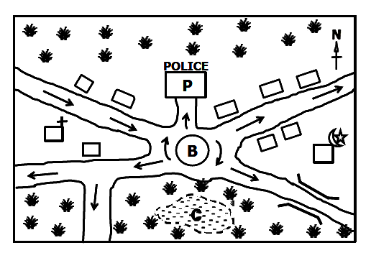The map extract below is of Malangala subcounty in Mityana district. Study it carefully and then answer the questions that follow.

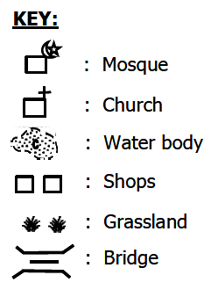

1. Identify the features marked **B** and **C** on the map extract.
2. **B** ……………………………………………………………………………………
3. **C** ……………………………………………………………………………………
4. Give **one** reason why you would carry out cattle keeping in Malangala

subcounty.

……………………………………………………..…………………………………………...

1. Write **one** social service the people of Malangala are lacking

according to the map extract

………………………………………………………………………………..…………….…..

1. (a) Which method of farming would you recommend to a farmer in;
2. steep slopes: …………………………………………………………………
3. very dry land: ………………………………………………..……….……..

(b) State any **one** factor which may hinder agricultural production.

………..…………………………………………………………………………………….….

(c) Which type of industries make finished goods out of agricultural

produces?

…………………………………………………………………………………………………..

1. (a) State any **two** factors which caused bankruptcy of the

Imperial British East Africa Company (IBEACO).

1. …………………………………………………………………………………………..
2. …………………………………………………………………………………………..

**7 Turn Over**

(b) Why was Uganda regarded as a British protectorate during

colonial times?

……………………………………………………………………………………………………

(c) Give any **one** way through which the British developed Uganda.

……………………………………………………………………………………………………

1. (a) State any **two** factors that have contributed to a decreased infant

mortality rate in Uganda today.

1. ………………………………………………………………………………………….
2. ……………………………………………………………………..…………………….

(b) Give any **two** ways you would advise the government to control

population growth.

1. …………………………………………………………..……………………………….
2. …………………………………………………..……………………………………….
3. (a) What role did Sir Apollo Kaggwa play during the signing of the

1900 Buganda agreement?

………………………………………………………………………..………………………….

1. State any **two** new changes that were made in Buganda just after

the 1900 agreement.

1. ………………………………………….………………………………………………
2. ……………………………………….…………………………………………………
3. Apart from treaties, write **one** other way the British used to make

Uganda a nation.

…………………………………..………………………………………………………………

1. (a) Give any **two** challenges facing regional economic blocs like

the EAC.

1. ……………………………………………………………………………………………
2. …………………………………………………………………………….……………..
3. State any **two** ways through which the EAC member states can

protect it from collapsing again.

1. ……………………………………………………………………………………………
2. ……………………………………………………………………………………………

**8**

1. Study the sketch map of East Africa and use it to answer the questions

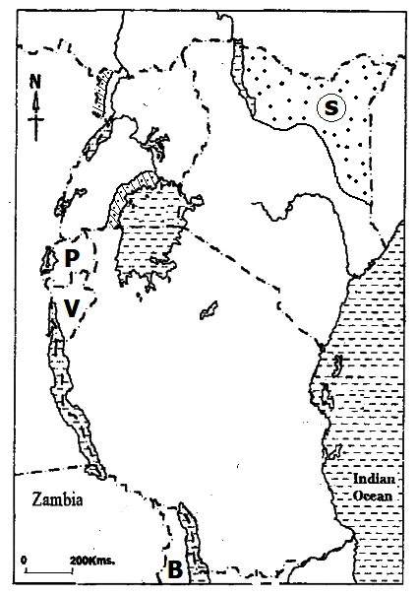that follow.

1. Name the East Africa’s neighboring country **B** on the map.

…………………………………………………………………………………………………..

1. Name the type of climate experienced in the shaded region of

Uganda.

…………………………………………………………………………………………………..

1. State the main economic activity of the ethnic group that settled in

area marked **S**.

…………………………………………………………………………………………………..

1. State any o**ne** challenge faced by the countries **P** and **V** resulting from

their strategic location.

………………………………………………………………………………………………………..

1. (a) In which ethnic group would you put each of the tribes below?
2. Bahima: ……………………………………………………………………….
3. Japadhora: ……………………………………………………………………….

(b) State any **one** reason why the Bantu people were easily attracted to

settle in the interlucustrine region.

……………..……………………………………………………………………………………

1. How did the migration of the different Ethnic groups into East Africa

affect the Bushmen?

…………………………………………………………………………………………………….

**9 Turn Over**

1. The diagram below shows the formation of a type of rainfall. Study and use it to answer questions that follow.

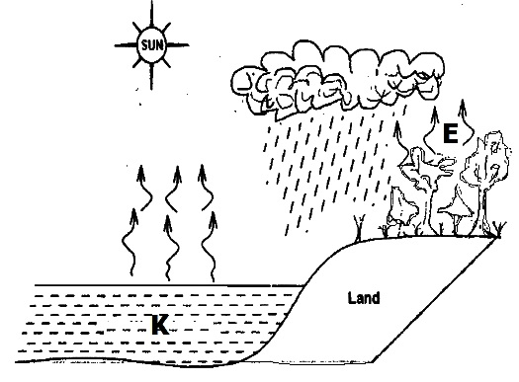

1. Identify the process marked **E**.

…………………………………………………………………………………………………

1. How does the feature labelled **K** contribute to the formation of

rainfall?

…………………………………………………………………………………………………

1. Name any **one** district in Uganda which commonly receives the type

of rainfall above.

…………………………………………………………………………………………………

1. Write any **one** economic activity carried out in places which receive

the type of rainfall illustrated above.

………………………………………………………………………………………………….

For each of the questions **51** to **55**, answer **EITHER** the Christian **OR** Islamic questions but **not** both. **No mark** will be awarded to a candidate who attempts

both alternatives in **a particular number**.

1. **FOR BOTH:**
2. Write any **two** reasons why it is important for the believers to visit

the sick.

1. …………………………………………………………………………………………
2. ………………………………………………………………………………………..
3. Mention any **one** common cause of sickness among believers.

……..…..…………………………………………………………………………………….

1. State any **one** way in which prophets were a symbol of hope for

the sick.

…….………………………………………………………………………………………….

**10**

1. **EITHER:**
2. State any **two** aims of the Uganda joint Christian Council.
3. …………………………………………………………………………………………
4. …………………………………………………………………………………………
5. Write any **two** challenges facing the Uganda Joint Christian Council.
6. ……………………………………………….……………………………………….
7. ………………………………………………………………………………………..

**OR:**

1. State any **two** aims of the Uganda Muslim Supreme Council.
2. …………………………………………………………………………………………
3. …………………………………………………………………………………………
4. Write any **two** challenges facing the Uganda Muslim Supreme

Council.

1. ……………………………………………….…………………………………..……
2. …………………………………………………………………………………..…….
3. **EITHER:**

*While we were with you, we used to say to you, “Whoever refuses to work is not allowed to eat.” We say this because we hear that there are some people among you who live a lazy life.*

***(2thes: 3:10-11)***

1. Write any **two** lessons you learn from the above quotation.
2. …………………………………………………………………………………………
3. …………………………………………………………………………………………
4. State any **one** effect of living a lazy life to a Christian.

…………………………………………………………………………………………………

1. Give any **one** reason why some people do not want to work.

…………………………………………………………………………………………………

**OR:**

*“Man will not get anything unless he works hard.”* ***(Surat Najm: 53:39)***

1. Write any **two** lessons you learn from the above quotation.
2. …………………………………………………………………………………………
3. …………………………………………………………………………………………
4. State any **one** effect of living a lazy life to a Muslim.

…………………………………………………………………………………………………

**11 Turn Over**

1. Give any **one** reason why some people do not want to work.

…………………………………………………………………………………………………

1. **EITHER:**
2. Give any **two** reasons why Christians should be tithe and offertories

in the church during worship.

1. …………………………………………………………………………………………
2. …………………………………………………………………………………………
3. Write any **one** item a Christian can pay as offertories during worship.

………………………………………………………………………………………………….

1. State any **one** reason why some Christians do not pay tithe and

offertories in the church.

…………………………………………………………………………………………………

**OR:**

1. Give any **two** reasons why Muslims should pay Zakat.
2. …………………………………………………………………………………………
3. …………………………………………………………………………………………
4. Write any **one** item a Muslim can pay as Zakat.

………………………………………………………………………………………………….

1. State any **one** reason why some Muslims do not pay Zakat.

…………………………………………………………………………………………………

1. **FOR BOTH TO ATTEMPT:**
2. What is suffering?

………………………….……………………….………………………………………………

…………………………………………………………………………………………………..

1. Mention any **two** causes of emotional suffering among believers.
2. …….…………………………………………………………………………………….
3. ……..……………………………………………………………………………………
4. State any **one** bad decision which may lead to suffering.

…………………………………………………………………………………………………..

**12 END**